* 1. **Propositional Logic**
* **Proposition:** A statement that declares a fact that is either true or false, but not both.
* **Propositional Variables:** Variables that represent propositions, e.g. p, q, r, s…
* **Truth Value:** The truth value of a proposition is denoted by T, if the proposition is true and F, if the proposition is false.
* **Propositional Logic:** Area of logic that deals with propositions. Developed by Aristotle.
* **Compound propositions:** Found from existing propositions using logical operators.

**Definition 1:** Let p be a proposition. The negation of p, denoted by ~p (read as not p) is the statement that “It is not the case that p.” The truth value of ~p is the opposite of the truth value of p.

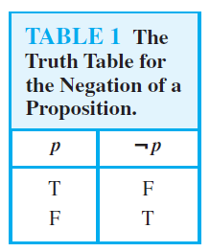

**Definition 2:** Let p and q be propositions. The conjunction of p and q, denoted by p˄q is the proposition p and q. It is true when both p and q are true and is false otherwise.

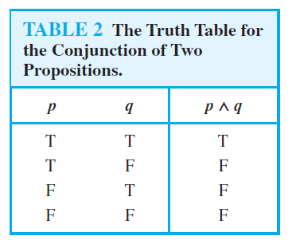

**Definition 3:** Let p and q be propositions. The disjunction of p and q, denoted by p˅q is the proposition p (inclusive) or q. It is false when both p and q are false and is true otherwise.

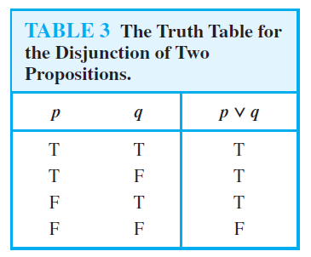

**Definition 4:** Let p and q be propositions. The exclusive or of p and q, denoted by pꚛq is the proposition p (exclusive) or q. It is true if exactly one of p and q is true and false otherwise.

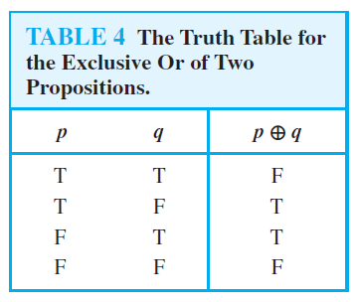

**Definition 5:** Let p and q be propositions. The conditional statement or implication p->q is the proposition “if p, then q”. It is false when p is true, and q is false and is false otherwise. p is called the hypothesis, antecedent or premise and q is called the conclusion or consequence.

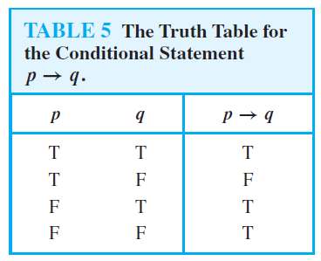

* **Converse:** The converse of p->q is q->p.
* **Contrapositive:** The contrapositive of p->q is ~q->~p.
* **Inverse:** The inverse of p->q is ~p->~q.
* The main statement and its contrapositive are ***equivalent*** (always have the same truth value).
* The inverse and converse are equivalent.

**Definition 6:** Let p and q be propositions. The biconditional statement or bi-implication p<->q is the proposition “p if and only if q”. It is true when p and q have the same truth values and is false otherwise.

